The Bob Stenehjem Memorial
North Dakota SHOOT-OUT

Thursday, September 4, 2025

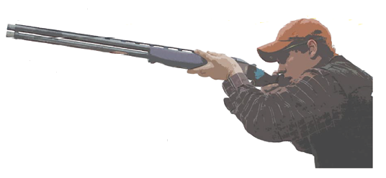

A Sporting Clay Fundraiser
Sen. Diane Larson Rep. Mike Nathe Rep. Glenn Bosch
Sen. Justin Gerhardt Rep. Todd Porter Rep. Nathan Toman


Capital City Sporting Clays
12951 71st Ave NE
Bismarck, ND 58501

Directions: I-94 East toward FARGO. Turn LEFT off EXIT 170 toward MENOKEN.
Turn LEFT onto 158TH ST NE and go 3.1 miles. Turn LEFT onto 71ST AVE NE and go 2.4 miles.
Capitol City Sporting Clays is on the LEFT.

Registration includes: shooting, ammunition, food, drink, prizes, a chance to sharpen your shooting skills before hunting season begins and a lot of fun!

- Individual Shooter $100
Station Sponsor $250 (includes two shooters/signage)

Checks made payable to: Dist 34 Republicans.
Mailing address: Mike Nathe 1899 Bonn Blvd Bismarck, ND 58504

Registration begins at 2:00 p.m. Shoot starts at 3:00 p.m.
Food and refreshments following the shoot.

Please RSVP to Mike Nathe at 701-319-1500 or email at mike@bismarckfuneralhome.com

